Virtual/Portable/Remote Office Checklist

Essentials

- Wireless Hot Spot or WiFi USB
- Private Cloud / Data Center
- Portable Back Up Battery
- Laptop Compatible Backpack
- Laptop

Add-Ons

- USB Car Charging Adaptor
- Triple USB Wall Charger
- USB Memory Stick
- Back Up Hard Drive
- Long Charging Cables
- Travel Powerstrip & Surge Protector
- Noise Canceling Headphones

ESSENTIALS

Mobile Hotspots vs. Wifi USB Sticks
Remote work starts and ends with the internet. Sure, it’s nice that you can “work offline” in Google Drive, but none of that matters if you can’t deliver on a deadline. Wifi can be hard to find on the road, so skip the crappy connection at the cafe and bring your own mobile wifi hotspot.

There are two types of mobile wifi devices—sticks and hotspots. They both provide wifi, but each has pros and cons.

Wifi Hotspot
- Provides wifi to multiple devices (phones, tablets, computers)
- No special software, just connect, enter the password and go
- Great for teams and heavy phone users
- Yet another device to charge and carry around
- Up to 20% latency speed vs USB direct device

USB Wifi Device
- Smaller & lighter
- No battery or charge to worry about, just plug and play
- Requires special software on your laptop
- Only provides wifi for one device (computer)

Aside from size (hotspots are bigger and heavier) and battery life (USB sticks don’t need to charge or plug into anything other than your laptop), the biggest difference is how many devices you can use on the same signal. A wifi hotspot can support a bunch of devices at once (although it slows down with each phone or laptop on the network), while a USB stick is just for your computer. It’s an obvious distinction, but worth mentioning, especially considering how much we do with our phones.

If you’re old school and do all the heavy lifting on your laptop, a USB wifi device do the trick. They’re smaller, easier to use, and inexpensive. If you and your team need to get online with laptops, tablets, and phones (and you don’t have the T-Mobile International Plan), a hotspot is your best choice. Here are some great mobile hotspot devices.

Panda Wireless USB Wifi Adaptor ($15)
The Panda is not as robust as other USB wifi devices, but you just can’t go wrong with this price tag.
Worth it for short trips especially.

Mobile Unite Explore Hotspot ($49)
AT&T has been the gold standard for mobile wifi for years. This device continues the legacy.
AT&T’s LTE network is robust, the battery life is fantastic (18 hours), and it just plain works. Splash-resistant and light (6.3 oz), this hotspot will let you get the job done.

The My Webspot 4G Pocket Wifi (€10/day)
The go to choice for mobile wifi in Europe. It accommodates up to 11 devices at once (although you’ll feel the lag). While the 6 hour battery life is a little short, the lack of any upfront device or network costs makes this hotspot perfect for short trips to Europe where work is necessary but secondary to the trip itself.

HooToo Wireless Router & 10400mAh Travel Charger ($39)
If you want to combine the speed of a travel router with a portable battery, the HooToo Wireless Router & 10400mAH travel charger ($39) is awesome. A great travel router and a massive travel charger with 10400mAh of power (that’s enough for five iphone charges) that lets you choose from three different wifi modes:

- AP (ethernet cable)
- Router (connect to a modem)
- Bridge (split a wireless connection into a safe channel)
Work from multiple devices or connect external drives via the USB ports for a mobile media center anywhere. This hub will help you transfer files, photos, videos, and more from your phone, or device, to the cloud or storage device, and at only 8 ounces, the HooToo travel router is very travel friendly.

Data Centers/Private Cloud

Portable Battery
I’ve written a lot about portable batteries, and while I have my favorites, every digital nomad has different needs, work restrictions, and tastes.

Flux Charger Plus (10,000mAh – $59)
If you’re seriously mobile, is the way to go. It packs enough punch for three full phone recharges on the go, holds a charge for weeks, and it’s tiny (7 oz). Even better, it features built in cables, so you’re always ready to charge, even if you’ve forgotten your cables. Toss this in your bag and forget about it until you need it.

Aukey 30,000mAh ($60)
If you’re a heavy mobile user this portable battery charger is the tank you need to keep everything—even your laptop—charged up. It’s got enough juice for many phone charges, and features 3 USB B and 1 USB C connection which means it can even charge multiple devices at once, including your computer. Invest in this heavy hitter.

Backpack

Laptop: 13” Macbook Pro
Your laptop is the workhorse of your portable office. It’s your mobile command center, your hub, and your money maker. I can’t tell you what to buy, only that you get what you pay for. I’ve worked on Google Chromebooks, tablets, smartphones, as well as budget laptops, and I can say with confidence that nothing ruins your chances of making it as a digital nomad faster than a crappy workstation.

Invest in your laptop. Buy a computer that you’ll use at home, not just something cheap and light “for the road.” You’ll hate using it, and all that lost time buffering on slow wifi connections won’t just be lost time and money, it will mean exponential amounts of frustration at working on the road and missing all the perks of living on the road. You’re not a “digital nomad” if you spend all day hunched over a crappy computer. You’re an idiot.

The 13” Macbook Air ($999) is light, kind of inexpensive, and easy to use. I recommend it for writers and part-time traveling digital nomads. However, this computer, while powerful, has trouble standing up to heavy render times for video editing, photo editing, and heavy usage on the road. The 13” Macbook Pro ($1299)while more expensive and heavier (4 pounds) is just simply a better machine for getting work done. It’s faster, better, and stronger.
The battery life is great (10+ hours), retina display is awesome (perfect for photo and video editing), and it’s just a mean machine. If you want to wait for a better version, Intel just announced their new 8th generation chip, and it’s expected to be a significant jump up in terms of processing speed and power.

Seriously, expect next year’s computers to outpace your laptop by 40% on day to day browsing and processing, and 10x that when it comes to heavy usage stuff like 4k video rendering and editing. If you’re waiting to upgrade your computer, now is the time.

Call me an Apple fanboy, but if you want to get work done, a Macbook Pro is the way to go. Make sure you back this up with a portable hard drive for more storage (more on that in a moment), but you can get a heck of a lot done with just your phone and your laptop.

ADD-ONS

Smartphone Accessories
You already have a phone, so this is not going to be a smartphone review. What I will suggest are smartphone accessories like a battery case and custom charging cables.

Mophie Phone Battery Case ($99)
The key to working on the road in a carry on bag is integration. A true digital nomad doesn’t have to “pack” for a business trip, because they’re already working from an extremely portable office set up. They back their data up in the cloud, collaborate across time zones on co-working platforms like Slack and Asana, and carry their portable office gear with them at all times.

Case in point—your phone case (see what I did there?). Unless you’re a savage, you already have a phone case to protect your mobile command center (your phone).
Why not upgrade this already existing piece of gear into something that doubles your phone’s battery life and protects your most precious possession?

The Mophie phone case battery packs are a no brainer, especially if you’re going to be away from reliable charging for most of the day, and/or you’re a heavy phone user. Not all apps are created equal, and depending on your workflow, you could be out of juice faster than the competition. Integrate your portable charging into your everyday phone usage and cut out an extra obstacle to productivity on the road.

ASUMI 3-Pack Nylon Braided Charging Cables ($11)
Don’t be that rookie huddled by the outlet at the airport charging your phone with a fragile, frayed cable. Get a cable that can take a beating and that actually reaches all the way to your seat.
The ASUMI charging cables are wrapped in braided nylon so they’re designed to flex and bend. This 3-pack (3ft / 6 ft / 10ft) lets you choose the length that’s right for you. The 6-foot cable is a solid everyday cable, but the 10-foot cable, while a tad bigger, more than makes up for it with the ability to charge your phone—and still sit in bed and use it—from just about any outlet in any room. Love these things.

Power & Charging

Triple USB Wall Charger ($9)
Forget dual USB wall chargers, snag this triple USB wall charging port and charge your phone, battery, and GoPro all at the same time. This charger is lightweight and compact, and the ability to get everything back to 100% in a single socket is a digital nomad hat trick that’s hard to come by, especially for under $10.

Belkin Power Strip & Surge Protector ($17.50)
If you need to recharge every night or work all day, this power strip features two independent USB ports on the side and a unique swivel design with four locking positions. The Belkin 3-outlet surge protector is compact and rugged enough to keep your expensive gear safe in any socket.
At only $17.50, it’s worth it.

Aukey Dual USB Car Charger ($10)
Rental cars are great, but never make assumptions when it comes to slick features like built-in USB charging. Bring your own cigarette lighter dual USB charging hub and never worry about GPS draining your phone battery again.
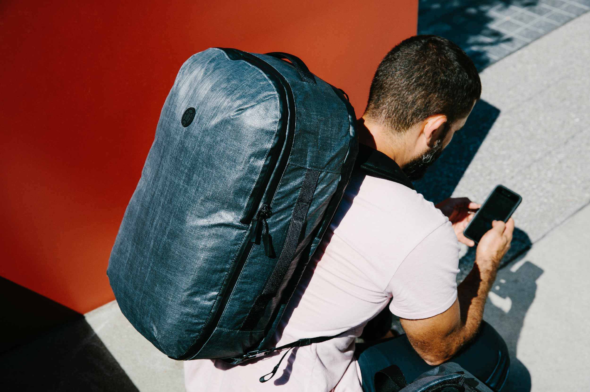

Evernote App
Leave the Moleskin behind and embrace the power of the cloud with Evernote. Evernote is more than a note taking app. This powerful idea storage tool is packed with features and tech that can make working on the road a breeze.
Evernote was already great for notes on the go, but they recently added insane functionality like keyword searchable notes, and image to text transcription, as well as geotags and time stamps to help you keep everything in order no matter how you work. What that means is that you can take a picture of some hand-written notes you jotted down on a napkin in Paris last year and Evernote can tell you where you were, when you took that picture, and even translate the words on that napkin into keyword searchable text.
That’s a game changer. Leave the paper and pen behind and keep all your ideas, photos, and travel history in one easy to search digital repository.

The only thing you really need for a portable office is your phone, computer, storage and an internet connection. Everything else lubricates the digital nomad experience, but won’t make you a success. Find a way to streamline your office gear as much as possible while making the little obstacles—charging, wifi, storage—as easy to overcome as you can.

When it’s easy to get work done, you’ll make more money and have the time to enjoy your “crazy” life on the road.

- Wifi is everything; invest in a hotspot that works
- Cloud storage is one less thing you’ll have to worry about (or pack!)
- Your laptop is key; don’t skimp
- A phone battery case is just a good idea
- Bring a few creature comforts: If you can’t get any sleep, you’ll never get any work done

CONTACT:

WIL MASTER
www.iWiLLMASTERdisaster.com
+1.213.290.6468
@iWiLLMASTER

